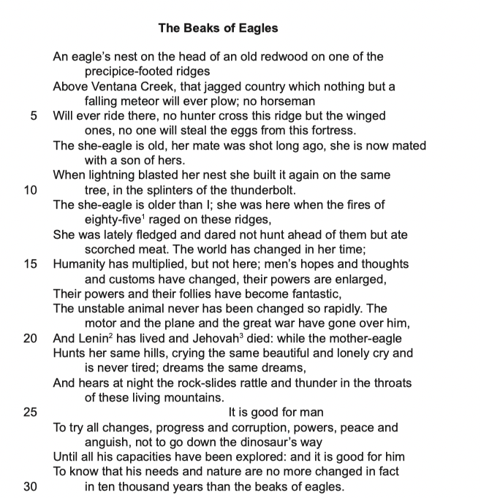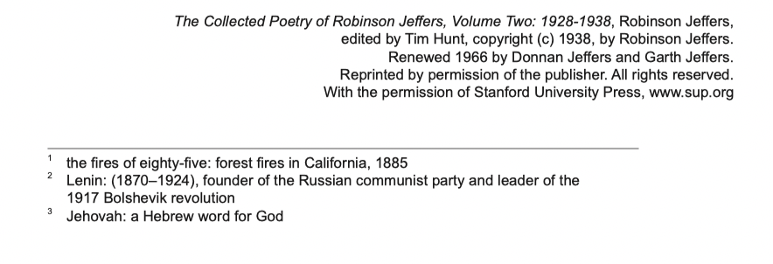

Uncomfortable with “mate with son” (son of Dedalus?) tricolon, three separate lists of two, connected as a group? Line 18 comparison, has happened recently, not long past.

Simply follows their genetic code, heroic devote themselves for a bigger benefit.\

In the behavior of she-eagle, she has resilience instead of diminish from the life, but adapt to it.

In tension with each other, can coexist, and have some relation but do not frequently appear in passages.

e.g. change v.s. stability

humankind v.s. nature

conflict leading to peace at last, have relation with Lenin’s opinion

Allusion with dinosaurs

***The below are the marking notes or broad guidelines (relevant to criteria A and B) provided by IB for assessing P1s based on this poem. Scores are of course not based on treating this like a mere checklist. Scores are based on the official rubric, and these notes are considered alongside language, organization, coherence of argument, and how a student engages with these and other factors.***

**IB marking notes:**

An adequate to good literary commentary will:

* have something to say about the representation of the eagle’s long life
* consider the connections drawn between the eagle’s life and the human world
* comment on the intensity of some of the diction and/or imagery
* show an awareness of the unchanging nature and/or perseverance of the eagle.

A very good to excellent literary commentary may also:

* connect the diction with the landscape
* consider the contrasts and parallels between the eagle’s life and human existence, perhaps including some reference to humans as the ‘unstable animal’
* explore the diction and imagery with greater depth and sophistication
* have something to say about the title of the poem and its reappearance in the last line
* discuss the importance of form and structure
* give some interpretation of the final short verse paragraph: this is a very challenging part of the poem and any reasonable attempt to unpack it should be credited.

……………………………………………………………………………………………………………………………………………………

***The below are my own notes on aspects of the poem’s meaning and techniques, and some good things to have incorporated into one’s response.***

**Some additional notes on effective responses to “The Beaks of Eagles”:**

**Some apt descriptors:**

Tone: Prophetic…

Imagery, diction, setting, or tone: Desolate, apocalyptic, vertiginous, terrible, terrifying, awesome, awe-inspiring, mythic, biblical, intense…

General associations of eagles: Majestic, heroic, noble, iconic, transcendent…

The poem’s “she-eagle”: Fierce, dominant, resilient, instinctive, persevering…

**Setting:**

Much of the imagery and focus of the poem is on its specific natural setting, and thus focus on that should form part of any good student response.

The setting has symbolic, allusive, and timeless qualities.

At the same time, the poem identifies it as a specific place and time: ridges above “Ventana Creek” at some point after the “fires of eighty-five”. Presumably the setting is contemporaneous with the time the poem was written.

From a specific point, then, the poem looks at all of nature and humanity with a cosmic scope.

**POV:**

The POV is that of speaker, who has a seeming omniscience and a prophetic tone that mark him as almost outside of time. Certainly, his perspective comes from standing apart from “unstable” human society, with their present and future-oriented concerns.

But the speaker inserts themselves into the poem with the phrase “the she-eagle is older than I”. The speaker is thus a specific individual at a particular moment in time and space. Their narrative of the eagle may be some combination of long, patient observation and their own imaginative speculation.

The statement “the she-eagle is older than I” also suggests that eagles, animals like them, or nature itself, has existed long before humans, or at least longer than conscious, reflective humans. The speaker is thus making himself a symbol of humanity, just as the eagle represents all eagles (or perhaps larger aspects of nature).

The speaker is perhaps inviting the reader to follow them in stepping outside themselves and their present moment to reflect on the awe-inspiring power of nature and human existence itself.

The perspective of the eagle herself is also subtly in play. The speaker’s detachment from human society, absence of self-reflection, and the apparent amorality of his perspective may be a reflection of his envisioning of the she-eagle’s experience of the world in the first section.

The speaker apparently admires the eagle, reflecting the poem’s respect for nature.

**Symbols:**

The she-eagle herself should be unpacked as a symbol. One should consider both “Why an eagle?” and the qualities given to the poem’s particular “she-eagle”. Is this eagle a symbol of certain human qualities, aspirations, or ideals (as we so often employ eagle symbolism), or rather an actual eagle? Clearly, she is the latter (though the speaker may nevertheless project certain qualities onto her, which could be explored as a secondary feature of the poem). This is thus a poem concerned with portraying nature accurately. One might interpret the she-eagle as embodying nature itself, or, perhaps more accurately, as life within nature, or as certain kinds of life (e.g. the kind with dominant qualities), or as life’s resilience and instinct for survival.

The poem’s “horseman” and “hunter” and the implication of farming with the reference to “plow” are noteworthy. These are archetypes (thus inherently symbolic) rather than distinct human characters (of which none are represented in the poem). They are primal: they are modes of human action which have existed since the earliest civilizations, thus at once maintaining the poem’s portrayal of the eagle’s habitat as a kind of timeless space and making us conscious of the vast scope of time when viewed in the context of nature, and of course emphasizing the poem’s theme of man’s unchanging nature. The association of man being able to ride a horse, farm the soil, and hunt animals suggests humankind’s ability to intelligently utilize nature for our own purposes. But the smallness of these figures relative to the eagle, and the “impenetrable” aspects of her environment suggest nature remains dominant.

Natural forces like the “lightning” and “meteor” stand outside both human and eagle and pose a threat to each. They call to mind superstitious fears of such things in past times and our modern scientific awareness of them which renders them no less wonderous. The focus on these elements as well as the natural elements of the eagle’s environment creates a palpable sense of the universe as alive with energy and prone to changes (though at a much slower rate than modern mankind’s changes) and material existence as something awe-inspiring.

The reference to not going “down the dinosaur’s way” combined with the reference to the “meteor” suggest the possibility of human extinction.

The shift to the focus on “man” in the poem’s closing section suggests that this is at least as much a poem about humankind as it is about nature. An impressive reading would connect the poem’s earlier symbolic elements to what it may be saying about humankind (in the modern age).

**Title:**

The reference to the eagles’ beaks in both the title and the final line basically makes this symbol scream out for analysis.

Appropriately, one thing the eagles use their beaks for is to emit their distinctive cry. Is this poem similarly a fierce proclamation, natural and “true” like the cry of the eagle?

Less lyrically, eagles also use their beaks for devouring their prey, so the symbol may emphasize their (and perhaps nature’s, humankind’s) need to eat, or their predatory survival drive.

The emphasis on beaks also recalls (alongside the poem’s reference to man as an “animal”) Darwin. He studied of various birds’ beaks as evidence for his theory of evolution. This is clearly a poem informed by Darwin. Evolution calls to mind those features that have been passed down to us over millions of years.

This could be read in different ways to support different readings of the poem’s perspective on humankind. One example: If eagles have developed their distinctive beaks because those have helped them to survive, then perhaps our evolved features (e.g. superior intelligence) will continue to help us to survive. Alternately: What makes humankind distinctive from the eagle is that our evolved feature, intelligence, has rendered us “unstable” as we are turning it towards creating technologies or ideologies that are helping to destroy us.

Perhaps most significantly, the focus on the eagle’s beak, as opposed to the eagle itself, makes us focus on the material. Instead of being awed at the eagle because of its majestic qualities or the nobility we project onto it, the poem prompts us to be awed at material itself: at the very chemicals and atoms that make up beaks, or perhaps that make up the genes that drive the eagle’s instincts. Nature is material, the very existence of which is mysterious and profound. (In this, there may be a parallel with the poem’s awe at humanity not as ideal beings, but as beings that exist in a fascinating and unique way.)

**Form and structure:**

There is no rhyme. There is no set meter.

There is no space between lines, and thus it is one long stanza.

The poem mostly follows a pattern of alternating longer and shorter lines. There are three outliers to this pattern: Lines 17-18, 20-21, and 28-29.

Most sentences are long, and employ various forms of internal punctuation.

There is frequent enjambment. There are also many end-stopped lines. Caesura is often featured within lines.

The poem employs alliteration as well as the more subtle consonance and assonance.

The poem can be divided into the part that portrays the eagle, which is more narrative, and the part that describes humanity.

The huge indent on Line 25 signals this transition. This same line markedly shifts from the previous section’s narrative description (of landscape and eagle) to a proclamation (on “man”).

(Just noting some of the above would count as some kind of engagement with structure!)

As with many traditional poems (including sonnets – though this isn’t a sonnet!) the closing section constitutes a shift from the earlier section, and also conveys the poem’s meaning most directly, giving new context to the earlier section. The final lines (final sentence, in this case) are the most direct.

In contrast to the Frost poems we looked at, there are not specific structural details, such as punctuation marks, that seem to unlock meaning or add ambiguity. Rather, the poet’s distinctive overarching structure is what draws our attention and most bears analyzing.

**Themes:**

Is our nature like the nature of the eagle? Are we fierce, amoral, driven by instinct, and good at surviving through catastrophe?

Are we social creatures or, like the eagle, individualistic?

Can we ever change our own nature?

What does the early 20th century reveal about our nature? Our future?

Will humankind destroy itself, or survive the catastrophes we create?

What makes mankind distinctive among all creatures on Earth, in spite of (or perhaps related to) our unstable and destructive tendencies?

What makes nature (or the universe) worthy of our attention and respect?

What insights can we gain from reflecting on natural history or “deep time”?

Do we have a soul, or are we, like the beaks of eagles, merely material?

How might we transcend?

**The “final short verse paragraph” on humanity:**

It’s tempting to read the poem as critical toward humanity. The she-eagle, for one, is an apparent subject of admiration, and her stable qualities are contrasted with those of “the unstable animal.” Further, the reference to the Great War and the death of Jehovah highlight humankind’s destructive tendencies and even imply human existence may be meaningless.

But, looking more closely at the language, one sees that the poem’s view is more complex than that. The poem uncategorically states it is “good for man” to do all that he is doing – and to do more! It implores that he should exercise his instincts “Until all his capacities” -- for good or ill, it’s implied -- “are explored”. Man may be a mere “animal” and “unstable”, but he is one that can experience “progress and corruption, powers, peace and / anguish”. The poem’s diction suggests not mere folly but rather something epic and tragic: something poetic.

The poem does not refute that the human race is not progressing, or that its nature is not in line with our moral ideals, or that will ultimately disappear from this earth. Rather, it affirms all of those ideas (facts, perhaps), but responds with an affirmation of life and an appropriate awe at humankind, even in our fantastic “follies”.

**Modernism and historical context:**

This is a modernist poem, published in 1936. We discussed modernism in class. The post-war context (it references the Great War, e.g. World War I, and Lenin, who rose to power during WWI), Darwinian focus on nature as violent and survival-based, ambitious scope, and skeptical reflection on human nature (especially in relation to war, technology, and social instability) all reflect modernism, as does the non-traditional (not following a set poetic form or meter) structure. The use of the first person “I” also marks the poem as modern (standing in tension with the impression of the POV being imbued with omniscience and the clear influence of ancient texts on its style).

The reference to Lenin incorporates Communism, 20th century mass movements, and ideas of progress that the poem is skeptical of.

The death of “Jehovah” (the ancient Hebrew word for God) calls to mind Nietzsche’s quote that “God is dead", reflecting the modern era as one that is much less based around traditional religious faith (and the comforting aspects of religious perspectives). It could support a reading of the poem as atheistic or even nihilistic (though it’s worth noting that Nietzsche’s philosophy is actually life-embracing). The idea of an all-powerful, immortal God dying is also epic and terrifying in a way consistent with the poem’s imagery.

There are also aspects to potentially explore about its context as an American poem. (This detail is noted in the footnotes which were deliberately excluded from this exam, so not relevant in this case.)

**Literary tradition:**

Nature is a perennial subject of poetry. Any meaningful and accurate placement of this poem and the way it portrays nature within the (Anglophone) poetic tradition could be apt.

For example, Romantic poets value nature highly attempt to convey the sublime in their portrayals of nature. One could argue that Jeffers’ poem follows in the Romantic tradition, or that its apparent materialism diverges from that tradition.

**Biblical and classical features:**

“Epic” and “biblical” would be good words to describe the language or tone, as well as the imagery, and also the structure.

The poem’s appearance on the page recalls Biblical text. (See image pasted at bottom of doc.) Much like “Beaks”, the latter has no spaces between lines, but its verses render it broken up into sets of sometimes just one or two sentences, with one line indented and others not, and often with the bulk of a sentence falling on one line with its remainder falling on the following line rendering that line shorter. (NOTE: Upon further reflection, this connection may be tenuous.)

The poem is largely a narrative. It has no rhyme. There is frequent enjambment. All of this recalls both the Bible and classical epic poetry.

The line division choices seem deliberate: It is constructed with a sense of rhythm and structure but without following any strict metrical pattern. This recalls the Bible.

The employment of alliteration and repetition further recall epic poetry.

The poem’s omniscient POV, vast scope, and lyrical recounting of history (“…when the fires of / eighty-five raged…”) – especially history involving catastrophe – likewise reveal the influence of the Bible and classical epic.

The references to “man”, as opposed to “humanity” or “the human species”, are characteristic of the biblical and classical.

The repetition of structures like “no horseman will…no hunter cross…” and “hopes and thoughts and customs”, the use of passive voice in phrases like “their powers are enlarged”, as well as phrases which proclaim moral or universal truths with an air of authority (“It is good for man”) all deliberately recall the language of the Old Testament/Hebrew Bible in particular. The distance, omniscient perspective, and scope of the POV recall the narrative voice of books like Genesis and Exodus, and the poem’s narrative of travails and resilience in a barren landscape recall the latter book in particular. The desolate mountain setting and the reference to “fires” there recalls the story of Moses and the burning bush. The imagery of vast destruction and suggestion of a possible human extinction call to mind the prophets and the Christian idea of the apocalypse. (Since you guys are not expected to have much familiarity with the Bible or Western religious concepts at this point, it would be impressive if you incorporated anything like this. There is more of an expectation you will catch at least some of the classical elements, however.)

Alongside the POV and voice, the poem’s emphasis on the immense power of nature and its personification (“the throats of these living mountains”), along with the references to thunderbolts (recalling Zeus) and the eagle’s incest (a trope of many myths), makes clear the poem is engaging with the classical. (There may be other connections as well: The eagle’s untouchable fortress may also recall Mount Olympus, for instance.)

The classical elements add nuance and power to the poem’s engagement with themes of nature and humanity’s relationship to it, human nature, and fate. One could argue that understanding this context is essential to truly “getting” the poem.

The poem’s non-condemnatory attitude toward humanity, and in particular humanity’s violence and warlike tendencies, recalls classical perspectives which, rather than harshly judging human morals as Christianity does, celebrate human power and heroism while at the same time viewing humans as victims of fate or the gods’ will.

The reference to things that humans have themselves produced having “gone over” humankind emphasizes the prominence of fate in the poem’s perspective, suggesting the complex dynamic between fate and free will (with fate presented as dominant) engaged with in classical tragedies like Sophocles’ *Oedipus*.

The eagle, as a symbol, also has classical associations.

Via its classical associations, the eagles is connected with militaristic civilization and with prophecy: both features are relevant to this poem. (The eagle in particular was adopted as an icon of Roman civilization, and military units would carry eagle symbols as the embodiment of their spirit. Even prior to that, the eagle and other birds of prey were, in the classical world, associated with augury: predicting the future based on apparent omens, especially the behavior of birds. The behavior of birds of prey was particularly associated with omens of the outcome of wars.) (Any reference to this would be quite impressive.)

The admiration of nature, the awe at its power, and the use of mythic or pseudo-religious language in reference to it all suggest – alongside the poem’s skepticism toward monotheism – a kind of pagan perspective: that is, a return to a primal near-worship of nature itself, alongside a recognition of our relative powerlessness within it. Perhaps imagining that the poem “worships” nature would be going too far, but it seems to recognize its primacy and value it inherently (as opposed to, for instance, wanting to preserve nature only to help ensure human survival).